**Shaft Weight:**

By taking the launch angle, swing speed, ball speed, swing path and face angle, we can find the correct length, weight, balance point, flex and design towards the fitting.

Once we find a total weight that gets your swing path as good as your swing will allow, we begin working on head weight to align the face angle of your club to the swing path. Changing the head weight on your clubs (this is measured by swing-weight or MOI) will determine how much your shots curve in flight. If your swing path and face angle are in alignment you will hit a straight shot.

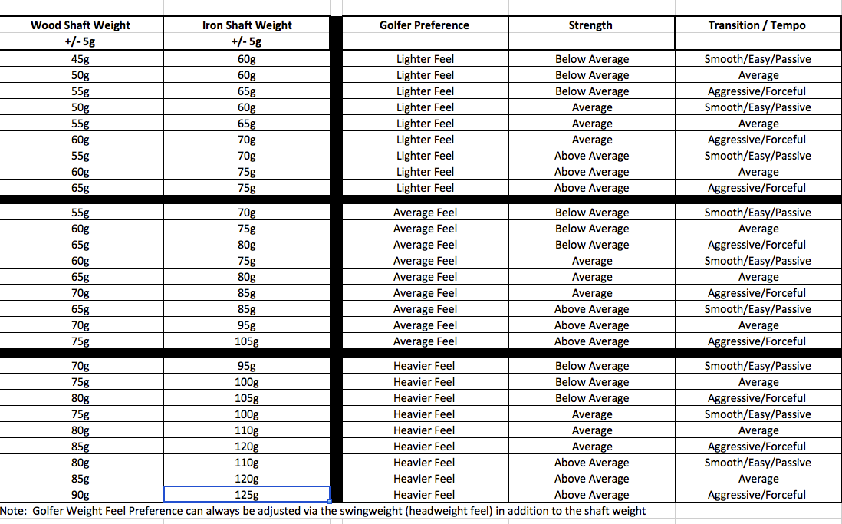

All experienced clubfitters know when fitting the weight of the shaft that the total weight of the club is being fit to the golfer at the same time. This is because shaft weight is the No. 1 determinant of the total weight of the club. Yes, grip weight and head weight have an influence on total weight, but they aren’t as important as the effect of the weight of the shaft. In short, when the golfer needs a lighter or heavier total weight in the clubs, fitting the weight of the shaft is how that is done.

<https://www.golfwrx.com/284141/wishon-what-shaft-weight-should-you-play/>